**EXPERIMENT 5**

**DDL COMMANDS (COLLEGE SCHEMA)**

**Aim:**

* **Create a schema called College.**
* **Create tables for students (attributes: student id, name, gender, subject, marks and grade), faculty (attributes: faculty id, name, course and pass percentage), department (attributes: department id, name, section, strength and pass percentage) and activity (attributes: activity id, name, strength and category)**
* **create schema college;**
* **create table student_1(student_id int, student_name varchar(20),gender varchar(20),subject varchar(20),marks int,grade varchar(10));**
* 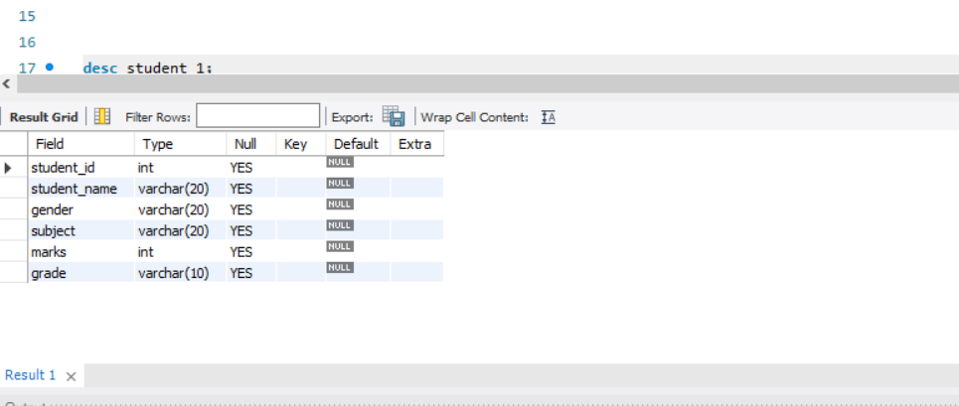
* **create table faculty_1(faculty_id int,faculty_name varchar(20),course varchar(20),pass_percentage int);**

**create table department_1(department_id int,department_name varchar(20),section varchar(20),strength int,pass_percentage int);**

**create table department_1(department_id int,department_name varchar(20),section varchar(20),strength int,pass_percentage int);**

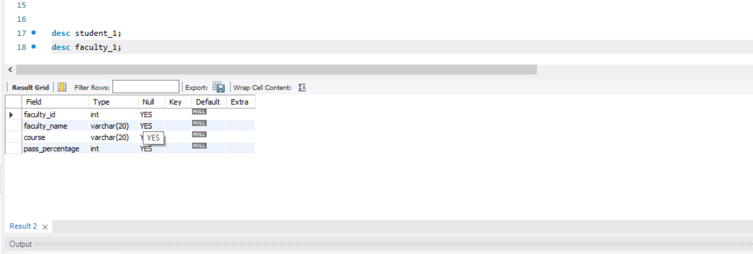

**create table department_(department_id int,department_name varchar(20),section varchar(20),strength int,pass_percentage int);**

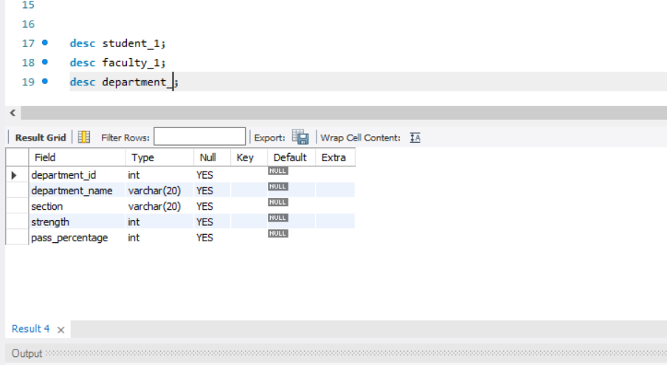

**create table activity_(activity_id int,activity_name varchar(20),strength varchar(20),category varchar(20));**

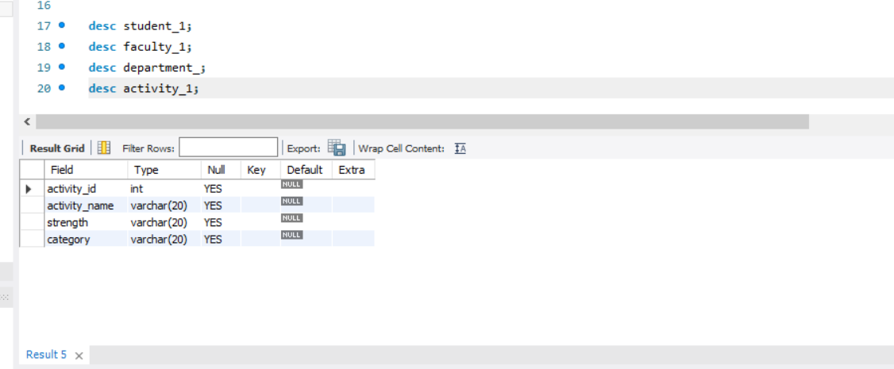

* Add and modify:
  + Address in students table, change datatype size of student name and make student id primary key

**alter table student_1 add(address varchar(30),primary key (student_id));**

**alter table student_1 modify student_name varchar(25);**

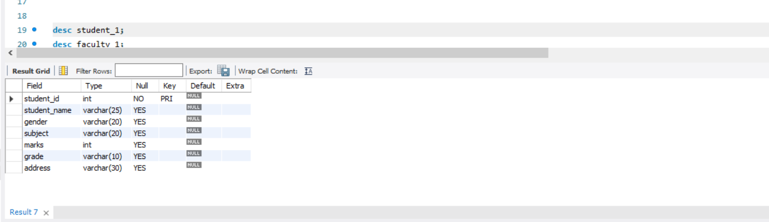

* + Add faculty total mentor details, make faculty id as primary key

**alter table faculty_1 add(mentor_details varchar(20),primary key(faculty_id));**

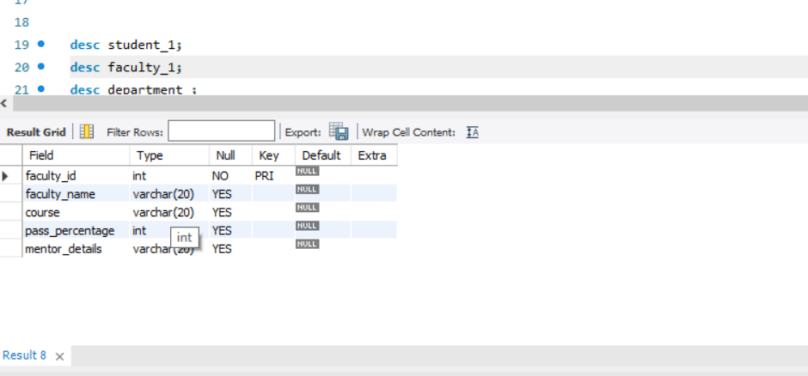

* + Add number of students in wise in department table and make department id as primary key

**alter table department_ add(no_of_wise_students int,primary key(department_id));**

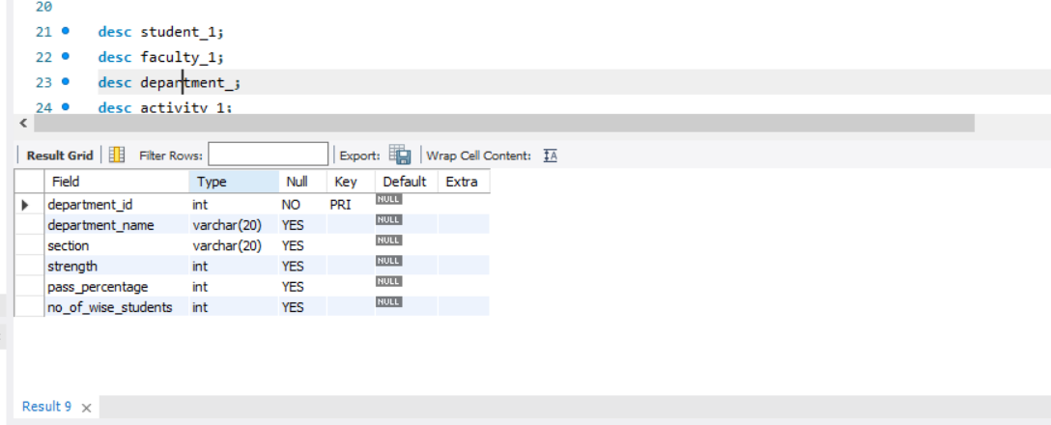

* + Add faculty name to activity table, change the datatype size of activity name and make activity id as primary key

**alter table activity_1 add(faculty_name varchar(20),primary key(activity_id));**

**alter table activity_1 modify activity_name varchar(25);**

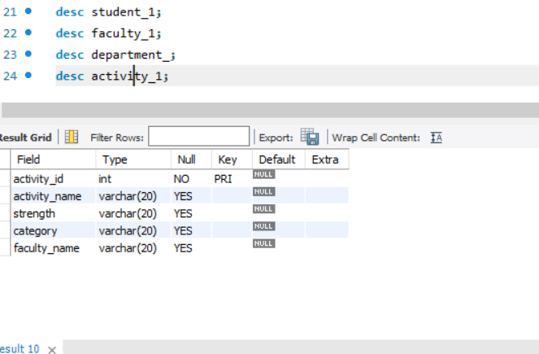

**alter table activity_1 modify activity_name varchar(25);**